**Gas Filling Station**

**Introduction**

This project is about creating a **Salesforce CRM application** to make gas filling station management easier. At many fuel stations, work like billing, keeping track of fuel stock, and managing customers is done manually. This takes time and sometimes leads to mistakes.

Our application solves these problems by using Salesforce. It helps gas stations to:

➤ Store customer details and purchase history.

➤ Manage petrol, diesel, and gas stock levels.

➤ Generate bills quickly and accurately.

➤ View daily sales and revenue reports.

With this system, gas stations can work faster, give better service to customers, and easily track their business performance.

**Salesforce**

**What is Salesforce?**

Salesforce is a **cloud-based software** that helps companies manage their business. It is mainly used as a **CRM (Customer Relationship Management)** tool.

**Creating Developer Account**

**Steps to Create a Salesforce Developer Account**

1. **Go to Salesforce Developer Site**

             ▪   Open your browser and visit <https://developer.salesforce.com/signup>

2. **Fill the Signup Form:**

            ▪ Enter your details:

                                 o First Name & Last Name

                                 o Email (use a valid one, you’ll get a verification mail)

                                 o Role (you can choose “Developer”)

                                 o Company Name (you can put your name or “Student Project”)

                                 o Username (must be in email format, e.g., yourname@crmproject.com)

3. **Verify Email**

          ▪ Salesforce will send a verification email.

          ▪ Open the email and click the verify link.

4. **Set Password**

           ▪ Create a strong password and security question.

5. **Login**

        ▪ Go to https://login.salesforce.com/

        ▪ Enter your username and password.

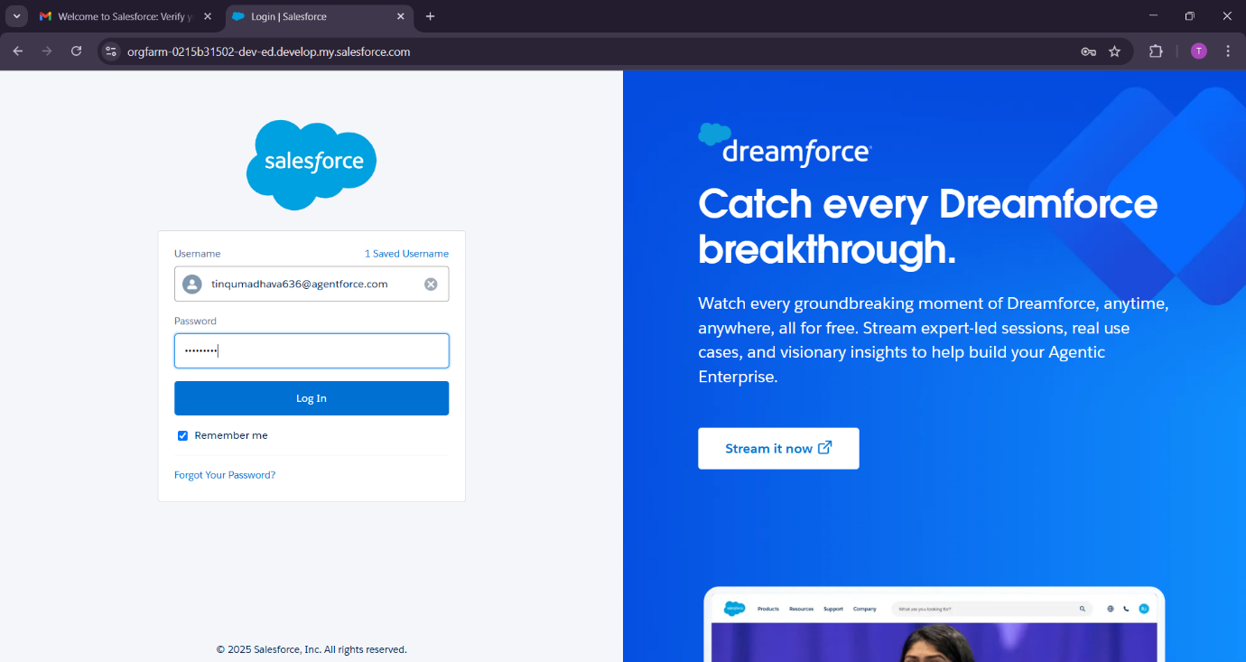

**Account Activation**

         1. After signing up, check your email from Salesforce.

          2. Open the email and click the verification/activation link.

          3. Set a new password for your account.

          4. Choose a security question and answer.

          5. Go to https://login.salesforce.com/ and log in with your username & password.

          6. Your Salesforce Developer Account is now activated and ready to use.

**Object**

**What Is an Object?**

        • An Object in Salesforce is like a table in a database.

        • It is used to store information (data) about something.

        • Each object contains records (rows) and fields (columns).

**Types of Objects in Salesforce**

1. **Standard Objects** – Already provided by Salesforce.

           ▪ Example: Accounts, Contacts, Leads, Opportunities.

2. **Custom Objects** – Created by developers for their own needs.

            ▪ Example: Fuel__c, Invoice__c, Customer__c for your Gas Station project.

**How to Create Objects**

**Steps to Create a Object in Salesforce**

**Create Supplier object**

        1. Login to your Salesforce Developer account.

        2. Click on the Setup (gear icon) in the top-right corner.

        3. In the Quick Find box (left side), type Objects → Select Object Manager.

        4. Click Create → Custom Object.

        5. Enter details:

                ▪ Label: Supplier

                ▪ Plural Label: Suppliers

                ▪ Record Name : Supplier Name

                ▪ Data Type : Name

         6. Click on Allow reports and Track Field History.

         7. Allow search and Save.

In such a way create remaining three objects such as

**➤**  **Gas station object**

**➤** **Buyer object**

**➤** **fuel details object**

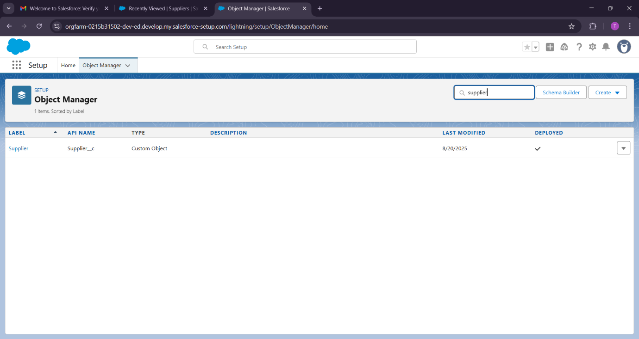

**Tabs**

**What is Tab ?**

          1. A Tab is like a button or menu in Salesforce.

          2. It helps you open an object and see its records.

          3. Each Tab shows data stored in one object (like Customers, Gas Stations, Buyers).

          4. Tabs make it easy to navigate and quickly access information.

          5. There are two types:

                   ▪ **Standard Tabs** → Already given by Salesforce (e.g., Accounts, Contacts).

                   ▪ **Custom Tabs** → Created by you for your own objects (e.g., Gas Station, Buyer  ).

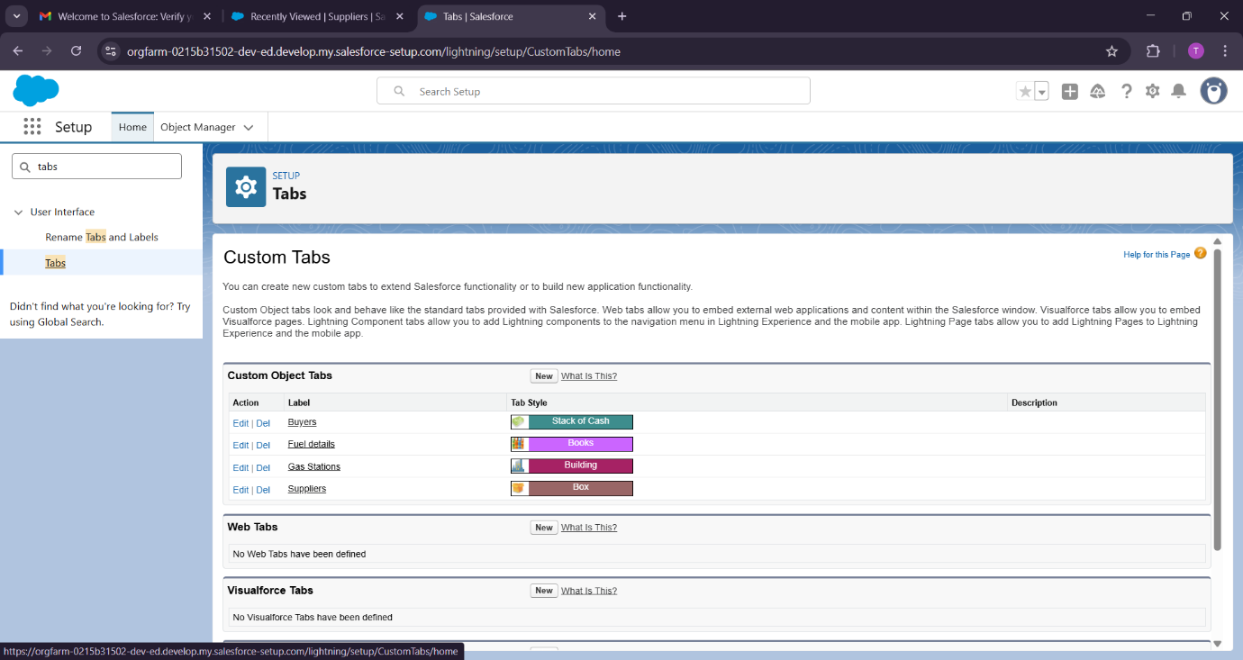

**The Lightning App**

**•** The Lightning App in Salesforce is a custom workspace where we can add different tabs and tools together to make our work easy.

          • In my Gas Station project, the Lightning App is used to group tabs like Gas Station, Buyer, Supplier, Fuel Details, and Receipt in one place for easy access.”

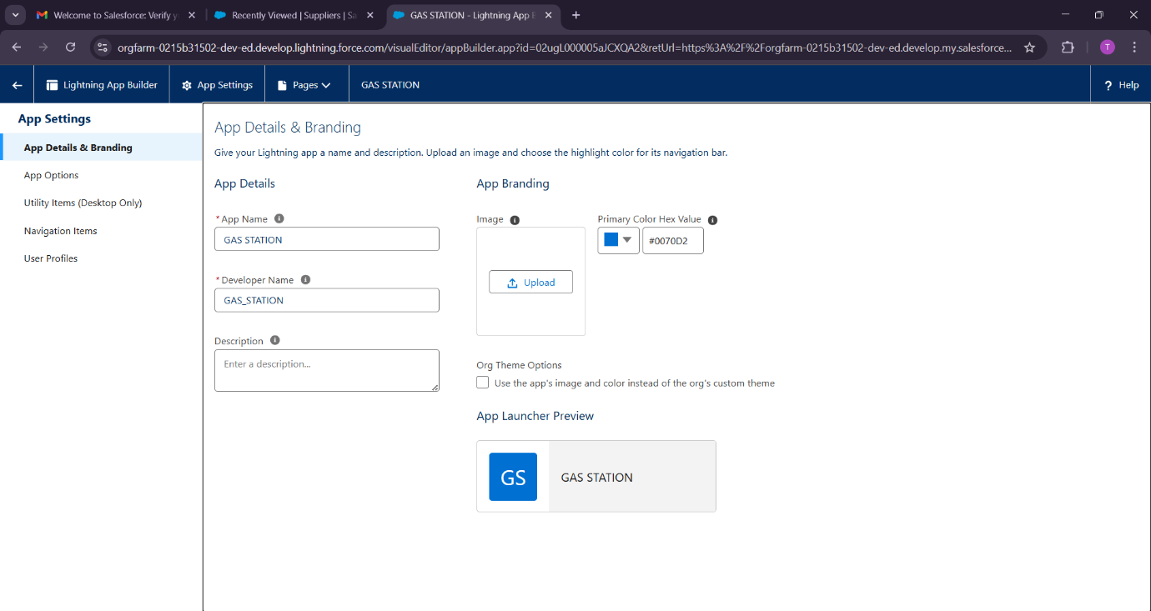

**Fields**

**What is Fields ?**

• A Field is a place inside an object where we store one type of information.

• It is just like a column in a table or Excel sheet.

• Each record (row) has values for these fields

**Types of Fields**

1.**Standard Fields** → Default fields given by Salesforce

2.**Custom Fields** → Fields created by you for storing extra information

**Steps to Create Fields**

1. Login to Salesforce.

2. Click on Setup → go to Object Manager.

3. Select the object (example: Gas Station, Buyer, Fuel Details,Supplier).

4. Click Fields & Relationships → then click New.

5. Choose the Field Type (Text, Number, Phone, Email, Date, Picklist, etc.).

6. Click Next.

7. Enter the Field Label (example: Contact Number, Fuel Capacity).

8. Set the Field Length/Options (for Text, Number, Picklist values, etc.).

9. Click Next → set Field-Level Security (decide who can see it).

10. Add the field to the Page Layout so it shows up in the record.

11. Click Save

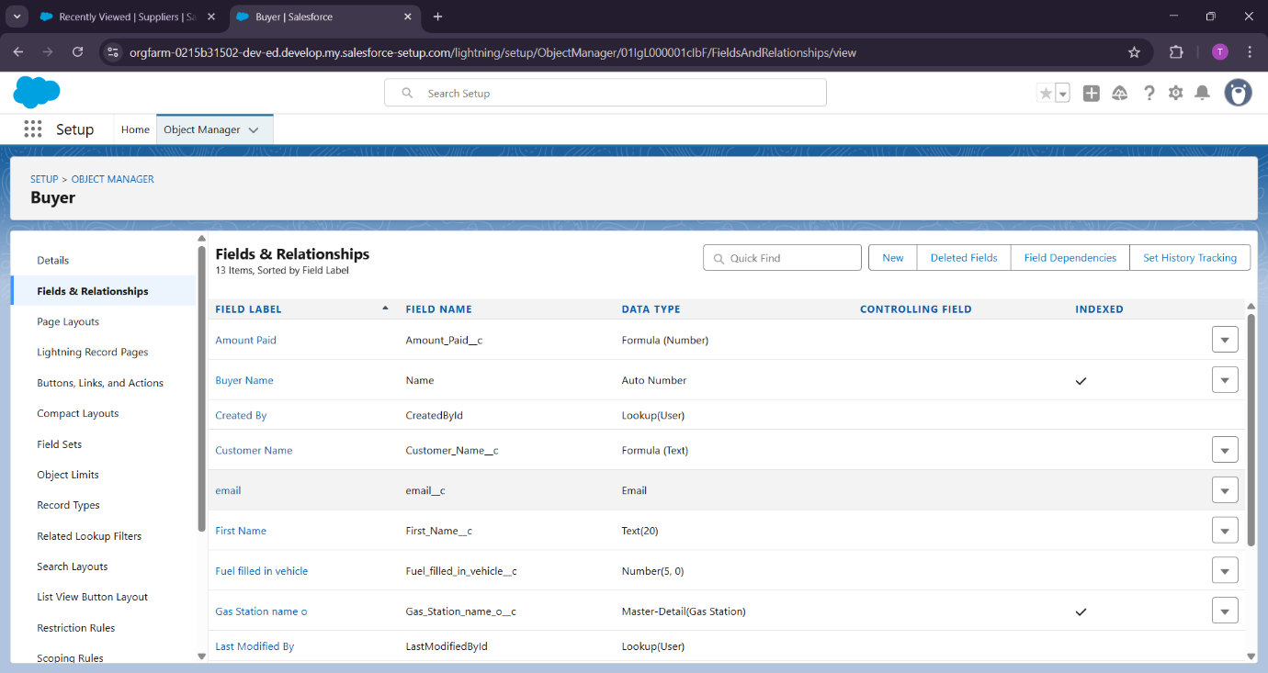

These are the fields which we have created for supplier object.

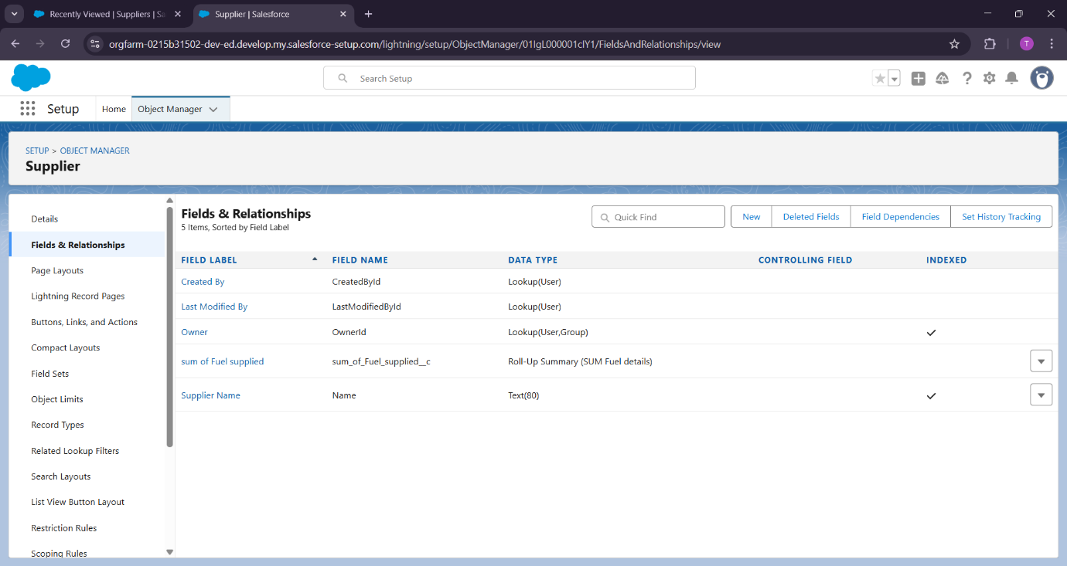

**Creating Formula Field in Gas Station Object**

A formula field is a custom field that can be used to calculate or display data on a Salesforce record.

Formula fields can be used to perform a variety of tasks, such as:

          • Calculating totals or averages

          • Creating custom fields that display data from other fields

          • Validating data entry

           • Automating processes

**create the junction object**

**In Object Manager** click on schema builder

* connect **fuel details ,gas station,supplier**.

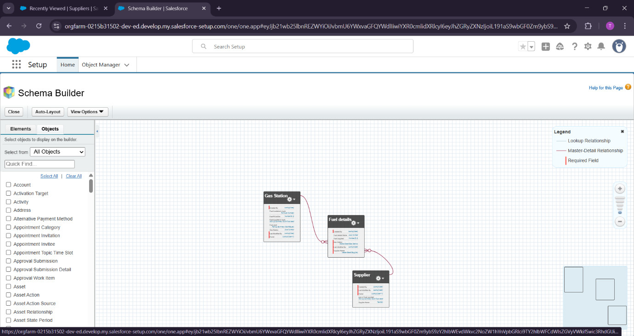

**Page layouts**

**What is Page Layout?**

         1. A **Page Layout** controls **how the fields, sections, and related lists** appear when you open a record in Salesforce.

         2. It is like the **design or arrangement of fields** on the record page.

         3. You can **decide which fields are visible, required, or read-only for users.**

         4. Different profiles (Admin, Manager, Staff) can have different page layouts.

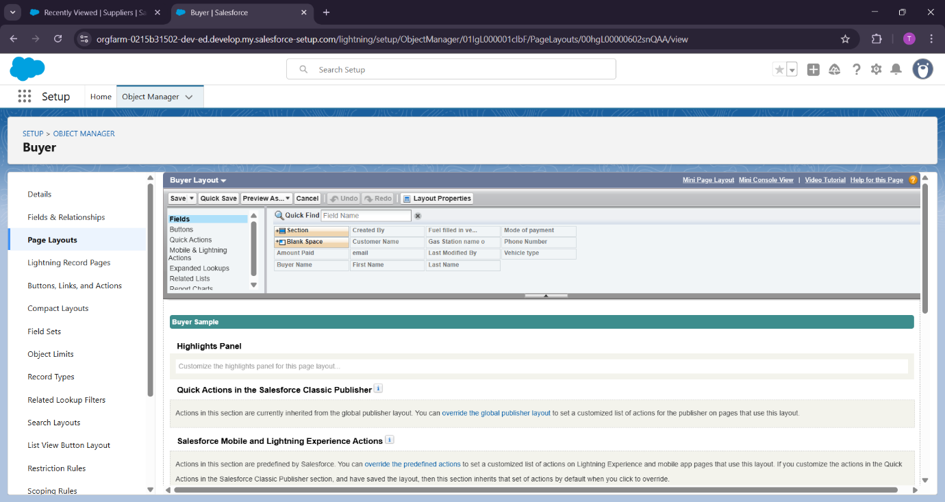

**creating the page layout**

           • Click on Setup → go to Object Manager.

           • Select the **Object** (Example: Gas Station, Buyer, Supplier,Fuel Details).

           • In the left panel, click Page Layouts.

           • To **create a new layout** → click **New.**

                   ▪ OR

                            To **edit an existing layout** → click on the layout name.

           • Use **drag and drop** to arrange fields, sections, and related lists.

          ▪ Example: Drag “Contact Number” under “Manager Info” section.

          • Click Save .

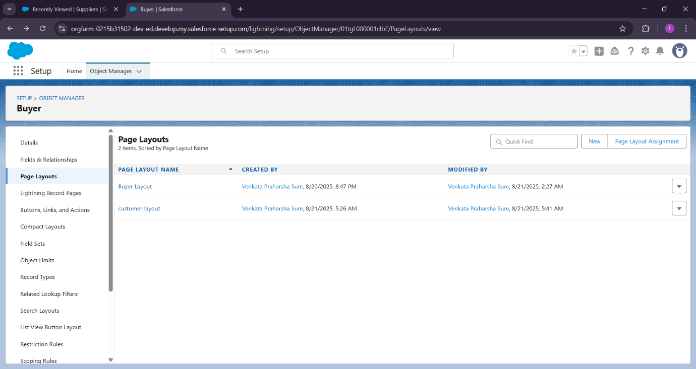

**Profiles**

**What is a Profile ?**

     1. A Profile in Salesforce defines what a user can do in the system.

      2. It controls:

                 ▪ Which objects a user can access.

    ▪ What fields they can see or edit.

    ▪ What permissions they have (Create, Read, Edit, Delete).

    ▪ Which apps and tabs they can use.

      3. Every user in Salesforce must have one profile

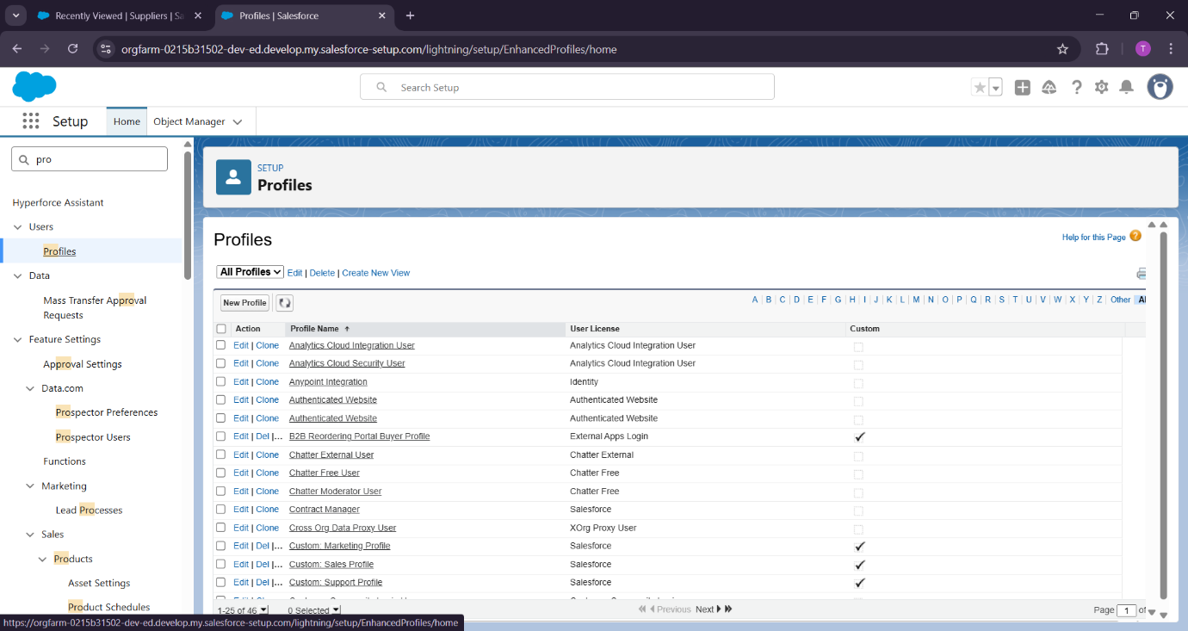

**Manager Profile**

         • Go to setup type profiles in quick find box click on profiles clone the desired profile (Standard User) enter profile name (Manager) Save.

**Sales executive Profile**

1. Click on Setup .

2. In the Quick Find box, type Profiles → click Profiles.

3. Click New Profile.

4. Select a profile to clone (best option → Standard User).

5. Enter Profile Name → **Sales Executive.**

6. Click Save .

Also create **Sales person Profile**

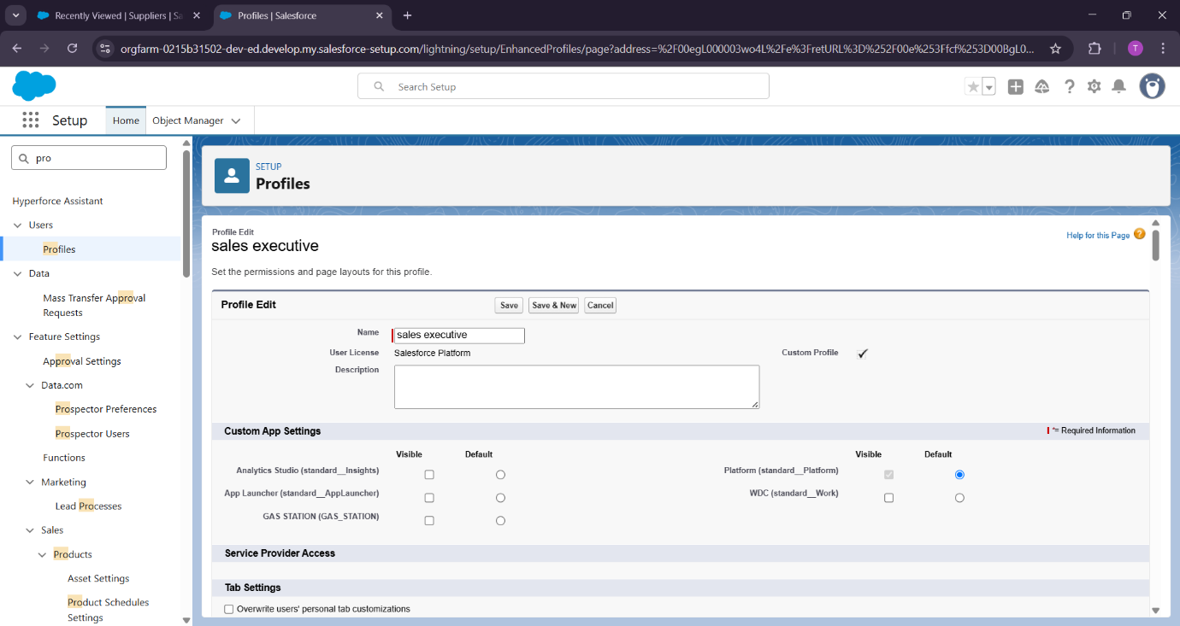

**Role & Role Hierarchy**

           • A Role defines what data a user can see in Salesforce.

           • It controls record-level access (who can view or share which records).

           • A Role Hierarchy is like an organization chart in Salesforce.

            • It ensures that higher roles can see the data owned by lower roles

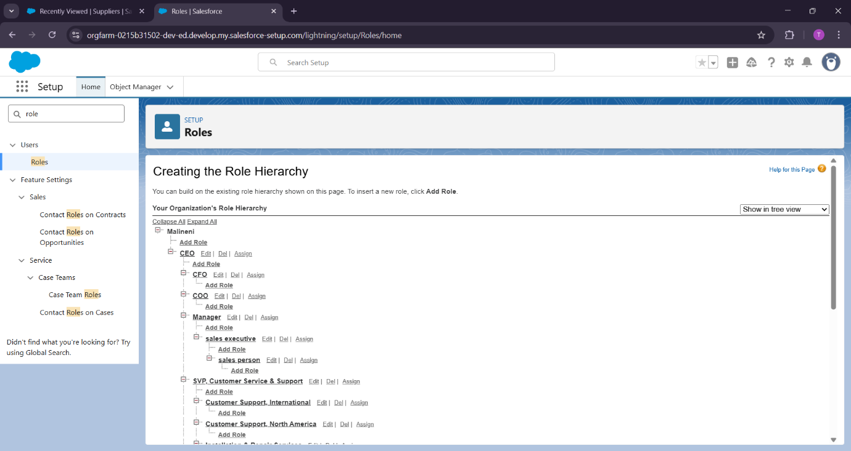

**Users**

**What is a User?**

           • A User in Salesforce is any person who can log in to Salesforce .

           • Each user has:

                         ▪ Username (like email)

                         ▪ Password

                         ▪ Profile (what they can do)

                         ▪ Role (what data they can see)

**Create User**

          1. Click on Setup (top-right corner).

          2. In the Quick Find box, type Users → select Users.

          3. Click on New User.

          4. Fill in the details:

                      ▪ First Name, Last Name

                      ▪ Alias (short name)

                      ▪ Email (user’s email address)

                      ▪ Username (must look like an email, e.g., salesperson@gasstation.com)

                      ▪ Nickname

                      ▪ Role (example: Sales Person, Manager, Sales executive)

                      ▪ Profile (example: Sales Person ,Manager, Sales Executive)

          5. Select User License (example: Salesforce,Salesforce Platform).

          6. Click Save.

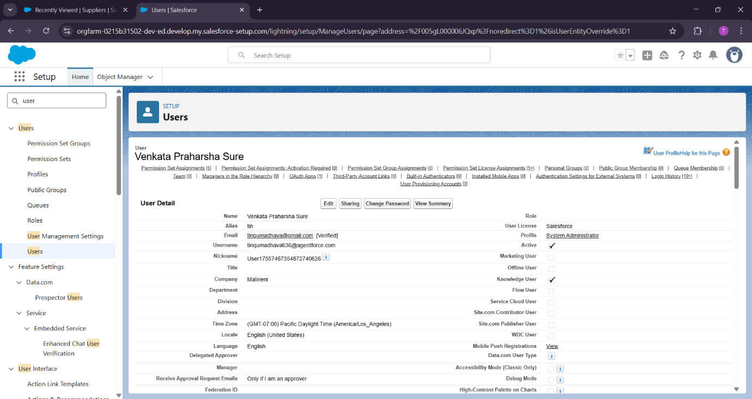

**Permission sets**

**What is Permission Set ?**

• A Permission Set is like giving extra keys to a user in Salesforce.

• It provides additional access/permissionson top of their Profile.

• Profiles decide basic access, but sometimes you want to give a little more access without changing the profile → that’s where Permission Sets are used.

**Creating permission set**

         1. Click on Setup .

          2. In the Quick Find box, type Permission Sets → Click on it.

          3. Click New.

          4. Fill in details:

                     ▪ Label → Example: Reports Access

                     ▪ API Name will auto-fill.

                     ▪ License → Choose the same as the user’s license (e.g., Salesforce).

          5. Click Save.

          6. Now open the Permission Set you created.

          7. Under System Permissions (or Object Settings), choose what extra permissions you want:

                  ▪ Example: Run Reports or Read/Write Fuel Details.

          8. Click Save.

          9. To give it to a user →

                       ▪ Click Manage Assignments → Add Assignments → Select the User → Save.

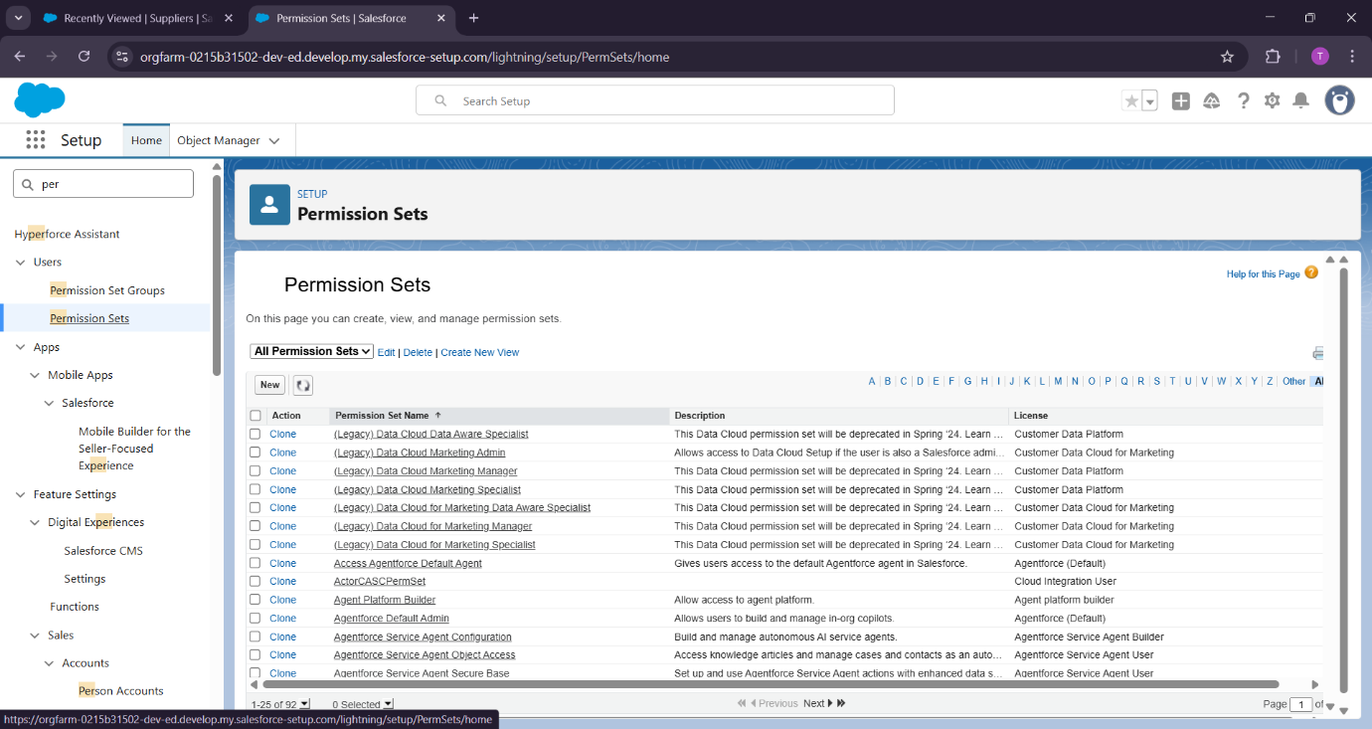

**Setup For OWD**

**What is OWD?**

         • **OWD = Organization-Wide Defaults**

         • It decides the baseline level of access users have to records they don’t own.

         • Example: If a Sales Person creates a Buyer, should other Sales People also see it?

**OWD Access Types**

1. **Private** → Only the record owner (and admins) can see it.

2. **Public Read Only** → Everyone can see, but only the owner can edit.

3. **Public Read/Write** → Everyone can see and edit.

4. **Controlled by Parent** → Record’s access depends on its parent object.

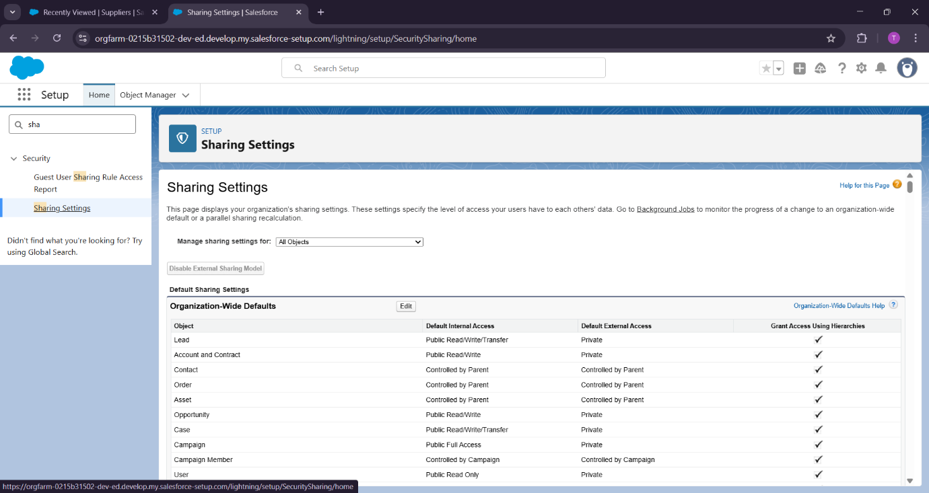

**Steps to Setup OWD**

            1. Click on Setup.

            2. In Quick Find, type Sharing Settings → Click on it.

            3. Under Organization-Wide Defaults, click Edit.

            4. For each object (e.g., Gas Station, Buyer, Supplier, Fuel Details, Receipt), choose the default access:

                        ▪ Buyer → Public Read/Write

                       ▪ Receipt → Private

                       ▪ Supplier → Public Read Only

                       ▪ Fuel Details → Public Read Only

                       ▪ Gas Station → Public Read Only

            5. Click Save.

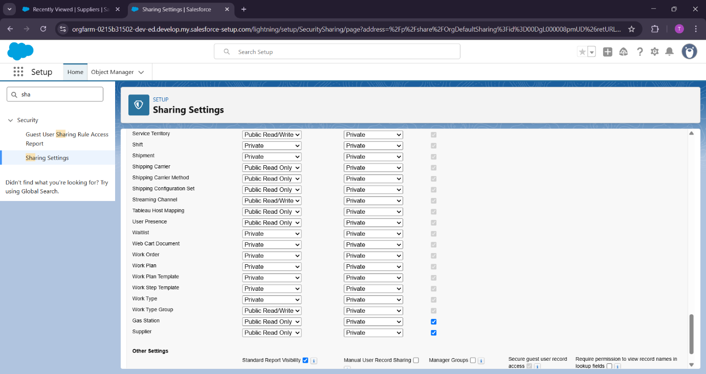

**User Adoption**

**create a record**

         • Click on the app launcher locate at left side of the screen.

         • Search for “ Gas station” and click on it.

         • Click on “ fuel details tab”.

         • Click on new and fill the details as shown below figs, and click save.

**View a record To create a record in junction object follow these steps**

         • Click on the app launcher locate at left side of the screen.

         • Search for “ Gas station” and click on it.

         • Click on “ fuel details tab”.

         • Click on the records that are already created.

**Delete a record To create a record in junction object follow these steps**

         • Click on the app launcher locate at left side of the screen.

         • Search for “ Gas station” and click on it.

         • Click on “ fuel details tab”.

         • Click on Arrow at right hand side on that Particular record.

          • Click delete and delete again.

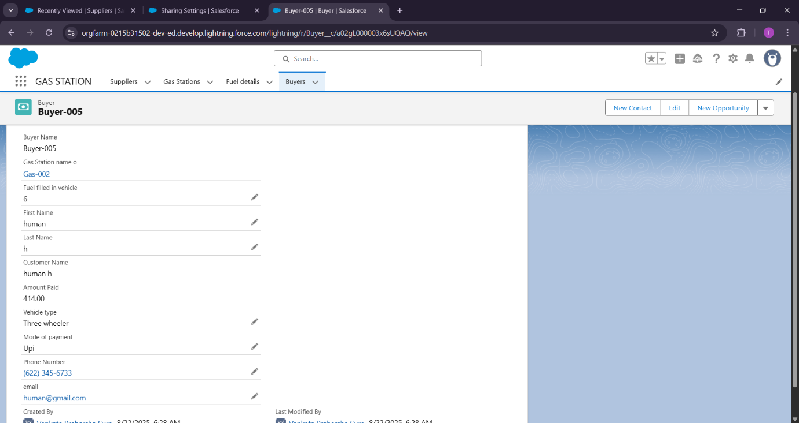

**Reports**

Report is a list of records that meet the criteria you define. It’s used to analyze data stored in Salesforce and present it in a structured way.

**Types of Reports in Salesforce:**

1. **Tabular Report** – A simple list (like an Excel spreadsheet).

2. **Summary Report** – Data with grouping (e.g., sales grouped by region).

3. **Matrix Report** – Data summarized in rows and columns (like pivot tables).

4. **Joined Report** – Combines multiple report types into one (e.g., opportunities + cases together).

**Create a report folder**

            • Click on the app launcher and search for reports.

            • Double click on the report, “ reports tab” will be autopopulated in navigation bar.

            • Click on the report tab, click on new folder.

            • Give the Folder label as “Fuel Estimation ”, Folder unique name will be auto populated.

            • Click save.

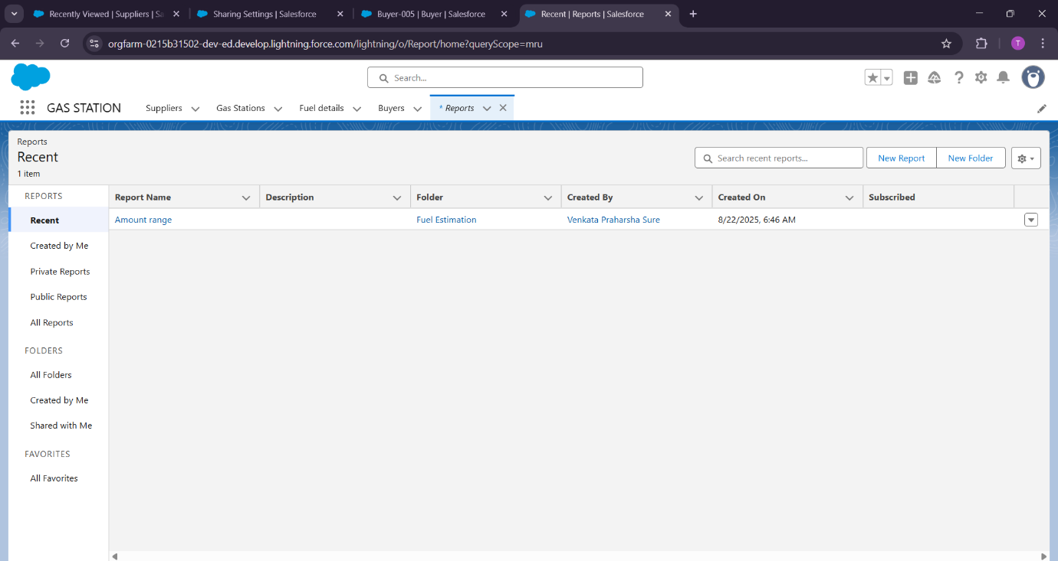

**Sharing a report folder**

             • Go to the app ? click on the reports tab.

             • Click on the All folder , click on the arrow for Fuel estimation folder, and Click on share.

             • Go to the app ? click on the reports tab.

             • Click on the All folder , click on the arrow for Fuel estimation folder, and Click on share.

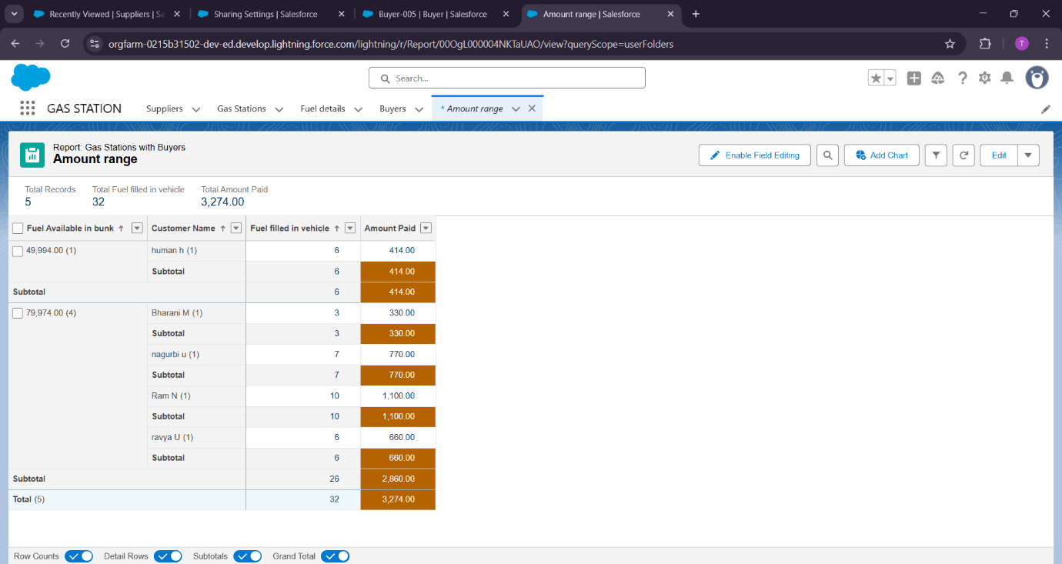

**Dashboards**

Dashboard is a visual representation of your data. It’s like a control panel where you can see multiple reports summarized in charts, graphs, or tables on a single page

**Create Dashboard Folder**

• Click on the app launcher and search for dashboard.

• Click on dashboard tab.

• Click new folder, give the folder label as “ **Amount estimation dashboard**”.

• Folder unique name will be auto populated.

• Click save.

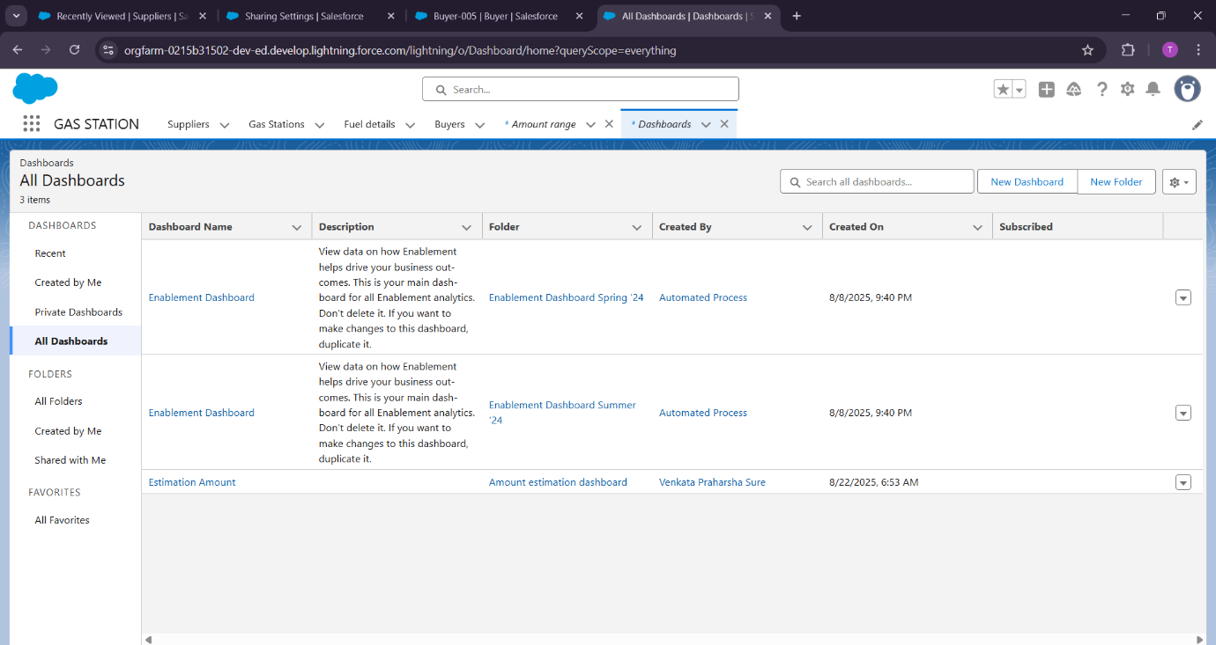

**Flows**

Flow is a tool to automate business processes without writing code. It lets you collect, update, create, or delete data and guide users through a sequence of steps.

**Types of Flows:**

1. **Screen Flow** – Requires user input; shows screens and guides users through steps.

2. **Record-Triggered Flow** – Runs automatically when a record is created, updated, or deleted.

3. **Schedule-Triggered Flow** – Runs automatically at scheduled times (e.g., every night).

4. **Autolaunched Flow** – Runs in the background without user interaction; can be called from other flows, buttons, or processes

**Steps to Create a Flow in Salesforce**

**Go to Flow Builder**

                     1. Log in to Salesforce.

                     2. Click Setup (gear icon) → Search for Flows in Quick Find → Click Flows.

                     3. Click New Flow.

**Choose Flow Type**

                      • You’ll see options like Screen Flow, Record-Triggered Flow, Autolaunched Flow, etc.

                      • For automatic updates when a record is created/updated → choose Record-Triggered Flow.

                      • For user input → choose Screen Flow.

**Configure Start**

             • For Record-Triggered Flow:

             ▪ Object: Lead

             ▪ Trigger: When a record is created (or updated, if needed)

             ▪ Condition Requirements: e.g., Lead Status = “New”

**Add Elements**

              • Click + to add elements like:

              ▪ Assignment → Assign the lead to a sales rep.

              ▪ Create Records → Create a related record if needed.

              ▪ Update Records → Update fields on this or related records.

              ▪ Decision → Add if/else logic (e.g., assign based on region).

              ▪ Screen → Collect info from a user (only for Screen Flow).

**Connect Elements**

            • Drag and connect elements in the order you want the flow to execut Save & Activate

        1. Click Save → Give a Flow Name and Description.

        2. Click Activate → Only active flows run.

**Test the Flow**

           • Create a new Lead (if record-triggered) → see if it automatically assigns the lead as expected.

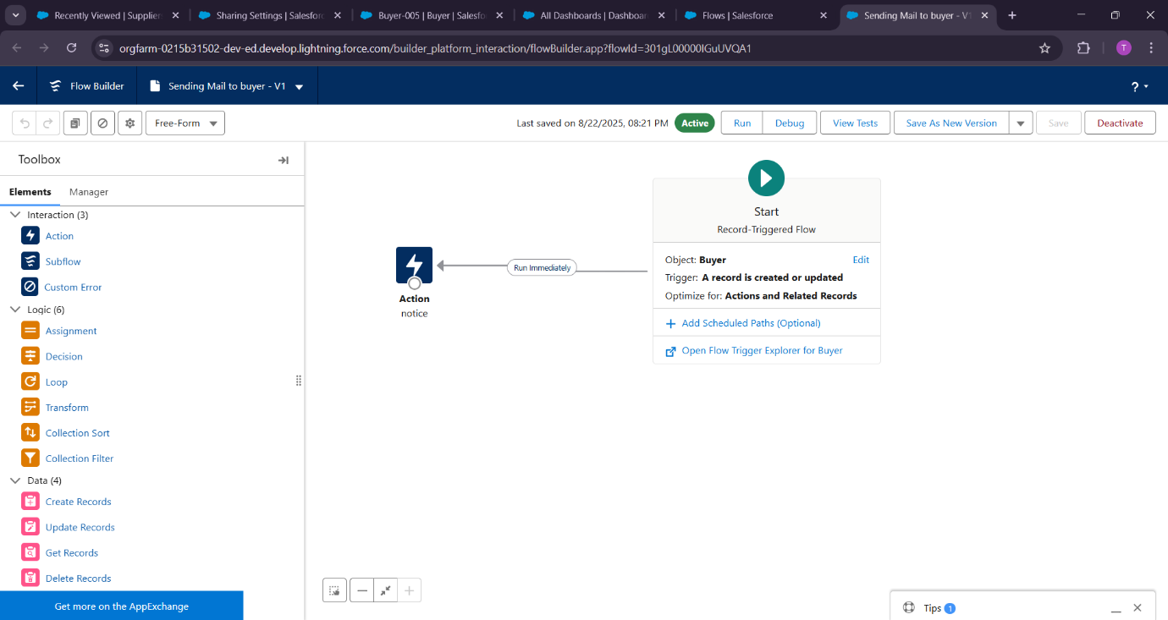

**Apex Trigger**

**Apex Trigger** is a piece of **code that runs automatically before or after records are inserted, updated, deleted, or undeleted.** It allows you to **perform custom actions that can’t be done using standard automation tools like Flow or Process Builder.**

**Trigger Events:**

* **before insert** : Before a new record is saved
* **after insert** :After a new record is saved
* **before update** :Before an existing record is updated
* **after update** :After an existing record is updated
* **before delete**: Before a record is deleted
* **after delete**: After a record is deleted
* **after undelete**: After a record is restored from recycle bin

